
DOI: https://doi.org/10.38035/jimt.v8i1
https://creativecommons.org/licenses/by/4.0/

Analysis of the Management Strategy for Mechanical-Electrical Facilities to Enhance Equipment Performance at Soekarno-Hatta International Airport

Abdul Malik Rosidi¹, Lira Agusinta², Yana Tatiana³, Mustika Sari⁴, Yuliantini⁵
¹Institut Transportasi dan Logistik Trisakti, Jakarta, Indonesia, malikirosidi@gmail.com
²Institut Transportasi dan Logistik Trisakti, Jakarta, Indonesia, lir4agusinta@gmail.com
³Institut Transportasi dan Logistik Trisakti, Jakarta, Indonesia, yana23011972@gmail.com
⁴Institut Transportasi dan Logistik Trisakti, Jakarta, Indonesia, mustika0017@gmail.com
⁵Institut Transportasi dan Logistik Trisakti, Jakarta, Indonesia, yuliantini6301@gmail.com

Corresponding Author: malikirosidi@gmail.com¹

Abstrak: Penelitian ini bertujuan menganalisis kondisi pengelolaan, kendala, serta strategi pengelolaan fasilitas mekanik elektro dalam meningkatkan performansi peralatan di Bandar Udara Internasional Soekarno-Hatta. Penelitian menggunakan pendekatan kualitatif dengan desain studi kasus. Data diperoleh melalui wawancara mendalam dan observasi terhadap 15 informan yang berasal dari Unit Engineering, Unit Pengguna/Ground Handling, Manajemen Aset, dan Unit Finance. Data dianalisis secara tematik menggunakan MAXQDA melalui proses coding, kategorisasi, identifikasi tema, serta triangulasi. Hasil penelitian menunjukkan bahwa fasilitas mekanik elektro secara umum masih mampu mendukung operasional bandara meskipun sebagian peralatan telah berusia relatif lama dan memiliki intensitas penggunaan yang tinggi. Performansi fasilitas dipengaruhi oleh keandalan teknis, beban operasional, kualitas pemeliharaan, ketersediaan suku cadang, kompetensi SDM, dan dukungan anggaran. Kendala utama meliputi keterbatasan anggaran, pengadaan suku cadang, gangguan teknis tidak terduga, keterbatasan personel, serta sinkronisasi data aset. Strategi peningkatan performansi diarahkan pada predictive dan condition-based maintenance, penguatan pemeliharaan preventif, penganggaran berbasis prioritas dan kritikalitas, peningkatan kompetensi SDM, serta penggantian aset secara bertahap. Penelitian menyimpulkan bahwa peningkatan performansi membutuhkan pengelolaan fasilitas yang terintegrasi, berbasis kondisi, risiko, dan siklus hidup aset.

Kata Kunci: fasilitas mekanik elektro, performansi peralatan, pemeliharaan, manajemen aset, MAXQDA

Abstract: This study aims to analyze the management conditions, constraints, and strategies of mechanical-electrical facilities in improving equipment performance at Soekarno-Hatta International Airport. A qualitative case study approach was employed. Data were collected through in-depth interviews and observations involving 15 informants from the Engineering Unit, User/Ground Handling Unit, Asset Management, and Finance Unit. The data were thematically analyzed using MAXQDA through coding, categorization, theme identification, and triangulation. The findings indicate that mechanical-electrical facilities generally remain capable of supporting airport operations, although some equipment has been in service for a relatively long period and is exposed to high operational intensity. Facility performance is influenced by technical reliability, operational load, maintenance quality, spare-parts availability, human resource competency, and budget support. The main constraints include limited budgets, spare-parts procurement, unexpected technical failures, limited personnel, and asset-data synchronization. Performance improvement strategies emphasize predictive and condition-based maintenance, strengthened preventive maintenance, priority- and criticality-based budgeting, personnel competency development, and gradual asset replacement. The study concludes that improving equipment performance requires integrated facility management based on equipment condition, operational risk, and asset life-cycle considerations.

Keywords: mechanical-electrical facilities, equipment performance, maintenance, asset management, MAXQDA

INTRODUCTION
As Indonesia’s principal aviation gateway, Soekarno–Hatta International Airport plays a strategic role in supporting domestic and international passenger mobility. The aviation industry experienced severe disruption during the COVID-19 pandemic, which significantly reduced aircraft and passenger movements and weakened airport revenues. PT Angkasa Pura II recorded only 35 million passengers in 2020, representing a decline of 44.18% compared with 2019. However, the relaxation of mobility restrictions and improvements in pandemic management stimulated a strong recovery in 2022, when passenger traffic across the company’s airports increased to approximately 62 million passengers. This recovery increased the operational demands placed on airport terminal facilities, including electrical, mechanical, and supporting equipment.
The fluctuations in aircraft and passenger movements between 2020 and 2022 were closely associated with the company’s financial performance. Declining traffic reduced both aeronautical and non-aeronautical revenues, while the company continued to bear substantial operating and maintenance expenses. PT Angkasa Pura II therefore implemented operational efficiency measures, including minimum terminal operations and expenditure prioritisation. At Terminal 2 of Soekarno - Hatta International Airport, these policies created a managerial challenge: the airport had to control maintenance costs while ensuring that terminal facilities remained reliable and complied with the required Level of Service. Reductions in maintenance expenditure may limit inspection activities, preventive maintenance, and spare-part availability, potentially increasing equipment downtime and disrupting passenger services during peak operating periods (Iwarue, 2025).
The performance of airport electrical and mechanical facilities is influenced by several interconnected factors, particularly equipment age, operational load, and maintenance frequency (Emtaubel et al., 2023). Older equipment generally has a higher probability of operational failure and may encounter problems related to performance degradation, spare-part scarcity, and rising maintenance costs (Prichard, 1984). At the same time, increasing passenger movements require facilities such as passenger boarding bridges, lifts, escalators, travelators, cooling systems, and baggage conveyors to operate close to their design capacities. High operating loads may accelerate component deterioration and increase maintenance expenditure (Ali & Ahmad, 2012). Maintenance frequency must therefore be determined carefully, because insufficient maintenance can allow minor problems to develop into major failures, whereas excessive maintenance may result in inefficient resource utilisation (Peng et al., 2024).
To address these challenges, the Terminal 2 Facility Unit has implemented facility-management initiatives involving three main dimensions: procedure, people, and parts. The procedural dimension includes the use of a Computerized Maintenance Management System (CMMS) to support preventive, corrective, and predictive maintenance (Crespo Marquez, 2023). The personnel dimension emphasises the technical competence required to maintain specialised airport equipment accurately and promptly. Meanwhile, the spare-parts dimension involves the use of compatible and equivalent components as alternatives to expensive original components supplied by manufacturers or authorised principals. These initiatives are expected to improve maintenance planning, predict component replacement requirements, reduce unnecessary expenditure, and preserve equipment availability (Aditya et al., 2015).
Previous studies have shown that equipment aging and intensive operational loads influence asset degradation, reliability, and maintenance requirements (Shrestha et al., 2024). Recent research also highlights the importance of optimizing maintenance strategies through predictive approaches and digital maintenance systems such as CMMS to improve equipment availability and cost efficiency (Zonta et al., 2020). However, existing studies generally examine these factors separately and have not comprehensively explained their interaction within airport facility management. Therefore, a research gap remains regarding an integrated maintenance strategy that combines asset condition, operational demand, maintenance practices, technical competence, and spare-part management under the operational and financial constraints of major airports.
The novelty and state of the art of this study lie in its integrated analysis of the actual condition, operational constraints, and management strategies for electrical and mechanical facilities at Soekarno-Hatta International Airport. Rather than examining maintenance factors independently, the study combines technical considerations equipment age, operational load, maintenance frequency, and spare-part availability with organisational measures involving CMMS, personnel competence, and compatible or equivalent parts. Accordingly, this study aims to analyse the current management of electrical and mechanical facilities in terms of equipment age, operational load, and maintenance frequency; identify the principal constraints affecting equipment performance; and formulate an appropriate facility-management strategy to improve the performance of electrical and mechanical equipment at Soekarno–Hatta International Airport.

METHOD
This study adopts a qualitative descriptive research design to examine the management of electrical and mechanical facilities and formulate appropriate strategies for improving equipment performance at Soekarno-Hatta International Airport. The research object encompasses the existing condition and management of electrical and mechanical facilities, particularly equipment age, operational load, maintenance frequency, maintenance costs, equipment performance, management constraints, and improvement strategies. The research population comprises personnel and stakeholders involved in asset management, engineering, facility utilisation, and maintenance financing at Soekarno - Hatta International Airport. The research sample, referred to as informants in this qualitative study, was selected through purposive sampling based on a minimum of two years of work experience, relevant knowledge, and direct involvement in facility management. The study involved 15 informants, consisting of one Asset Management Team representative, two Asset Management Unit personnel, six Engineering Unit personnel, three facility users from airlines or ground-handling companies, and three Finance Unit personnel. The research was conducted at Soekarno–Hatta International Airport.
The researcher served as the primary research instrument, supported by semi-structured interview guidelines, observation notes, and document-review forms. Primary data were collected through in-depth interviews and direct observations, while secondary data were obtained from asset inventories, maintenance records, Computerized Maintenance Management System (CMMS) data, facility Health Index reports, maintenance-cost reports, equipment-performance reports, applicable regulations, company annual reports, and relevant academic literature. The data were analysed using the interactive qualitative analysis model of Miles, Huberman, and Saldaña, comprising data collection, data reduction, data display, and conclusion drawing or verification. MAXQDA software was used to organise transcripts, conduct open, axial, and selective coding, develop categories and themes, and visualise relationships through the Code Matrix Browser, Code Relations Browser, and Summary Grid. The analysis focused on identifying patterns and relationships concerning equipment age, operational load, maintenance frequency, maintenance costs, equipment performance, CMMS implementation, technical personnel competence, spare-part availability, management constraints, and improvement strategies. The credibility and consistency of the findings were strengthened through source and technique triangulation by comparing evidence obtained from different informants, interviews, FGDs, observations, and supporting documents.

RESULT AND DISCUSSION
- Qualitative Data Processing Using MAXQDA
The qualitative data obtained from interviews on the management of mechanical-electrical (ME) facilities at Soekarno-Hatta International Airport were processed using MAXQDA software. All interview transcripts were compiled and analyzed through a coding process, in which statements were grouped into themes based on the focus of the study: facility and asset condition, factors influencing performance, constraints and obstacles, management processes and coordination, and performance-improvement strategies. The coding results were then visualized to reveal the pattern of relationships among categories, sub-categories, and data sources, thereby strengthening the interpretation of the research findings. The following sub-sections present the coding maps and coding tables for each category, followed by a concise discussion of the key findings.

- Facility and Asset Condition
The MAXQDA analysis for the Facility and Asset Condition category was carried out to identify patterns in respondents' statements regarding the actual condition of ME facilities. Coding in this category covers equipment age, utilization level (load), actual facility condition, the gap between the economic and technical service life of assets, and the planning/evaluation process. The resulting code map is presented in Figure 1.
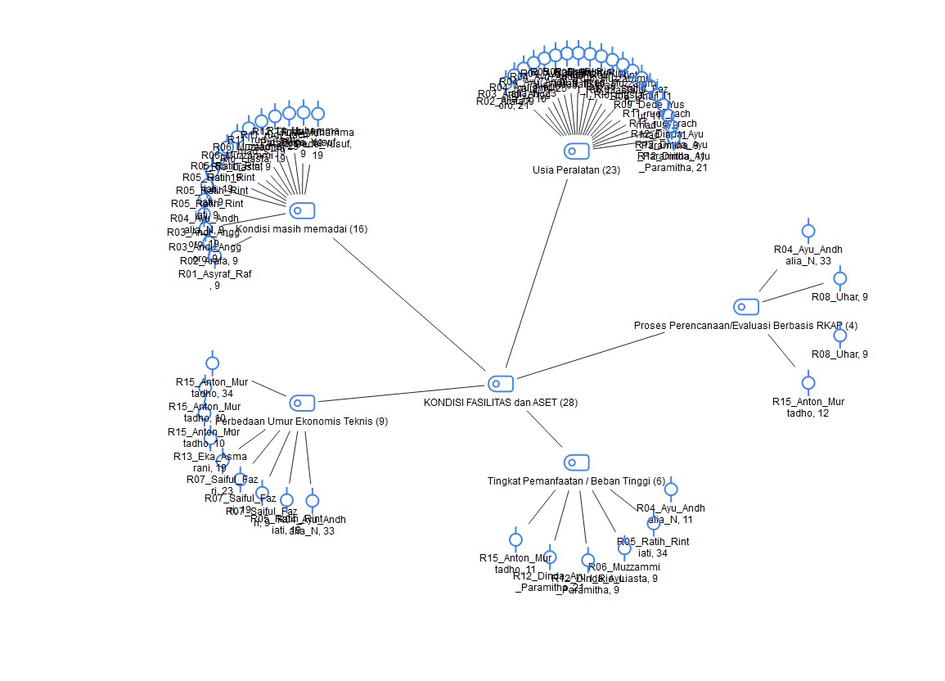
Figure 1. Coding Map of Facility and Asset Condition (MAXQDA)

Table 1. MAXQDA Coding Results Facility and Asset Condition Category
Code | Sub-category | Count | Reference Keywords
1.1 | Aging Equipment/Assets | 23 | age, economic life, service life, old, aging, exceeding lifespan, facility age
1.3 | Condition Still Adequate/Controlled | 16 | fairly good, still capable, adequate, still good, sufficient, quickly resolved, responsive
1.4 | Technical vs. Financial Economic-Life Gap | 9 | technical economic life, financial economic life, differing views, asset data, company records, valuation
1.2 | High Utilization/Load Level | 6 | load, utilization, dense, high, overuse, continuous operation, peak, flight volume
1.5 | RKAP-Based Planning/Evaluation | 4 | RKAP, condition evaluation, technical needs identification, budget proposal, budget formulation

The sub-category Aging Equipment/Assets is the most dominant theme (23 codes), indicating that equipment age is the aspect most frequently mentioned when respondents describe facility condition. However, a high frequency of age-related mentions does not necessarily mean that older facilities are unfit for use; this is confirmed by the sub-category Condition Still Adequate/Controlled (16 codes), which shows that many aged facilities can still support operations as long as maintenance and technical condition are maintained. The Technical vs. Financial Economic-Life Gap (9 codes) reflects respondents' awareness that an asset's recorded economic life does not always mirror its actual technical condition information that is important for maintenance and replacement decisions. High Utilization/Load Level (6 codes) shows that usage intensity is also considered part of condition assessment, given the airport's high-traffic operational characteristics. RKAP-Based Planning/Evaluation (4 codes), although the least frequent, confirms that facility condition is also embedded in the budget planning and evaluation process. Overall, these findings indicate that facility condition cannot be judged from age alone; it is shaped jointly by asset age, technical feasibility, utilization level, and the evaluation/management process, meaning aged equipment can still perform adequately if properly maintained, while heavily used facilities require greater management attention.

- Factors Affecting Performance
This analysis identifies the factors respondents associate with the ability of ME facilities to sustain reliability and support airport operations. Coding revealed technical factors, operational load, maintenance, spare-parts availability, budget, and HR competence, as mapped in Figure 2.

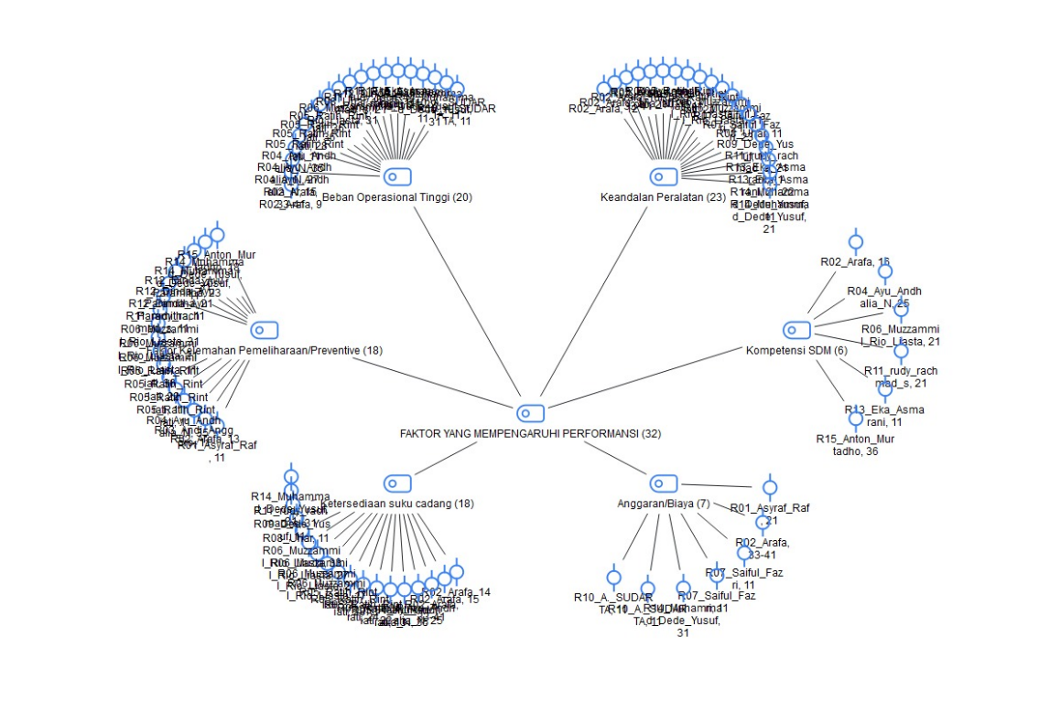
Figure 2. Coding Map of Factors Affecting Performance (MAXQDA)

Table 2. MAXQDA Coding Results Factors Affecting Performance Category
Code | Sub-category | Count | Reference Keywords
2.1 | Technical Factors/Equipment Reliability | 23 | reliability, technical, equipment quality, condition, input power, stable, component wear, main components
2.5 | High Operational Load | 20 | operational load, workload, continuous operation, high usage, usage frequency
2.4 | Spare-Parts Availability | 18 | spare parts, spare part quality
2.6 | Weak Preventive Maintenance | 18 | insufficient preventive action, maintenance quality, inconsistent maintenance, service quality
2.3 | Budget/Cost Factors | 7 | budget, cost, funding, CapEx, OpEx, revenue and expense
2.2 | HR Factors/Technician Competence | 6 | HR, competence, technician, expertise, personnel capability, technical knowledge

Technical Factors/Equipment Reliability is the most dominant sub-category (23 codes), followed by High Operational Load (20 codes) — showing that performance is closely tied to both the technical reliability of equipment and the intensity of its use, particularly during peak operational periods. Spare-Parts Availability and Weak Preventive Maintenance each appear 18 times, indicating that performance also depends on the managing unit's ability to maintain equipment consistently and secure required components; delays in either can slow fault handling and disrupt operational continuity. Budget/Cost (7 codes) and HR/Technician Competence (6 codes), though less frequent, remain relevant since maintenance execution requires both financial support and appropriately skilled personnel. Overall, facility performance is shaped by a combination of technical reliability, operational load, maintenance quality, spare-parts availability, budget support, and HR competence — meaning performance depends not only on physical condition but also on resource readiness and the supporting maintenance system.

- Constraints and Obstacles
This category identifies problems encountered in managing ME facilities. Coding shows that obstacles stem not only from technical issues but also from budget, handling time, human resources, operational load, asset-data management, and inter-unit coordination, as shown in Figure 3.
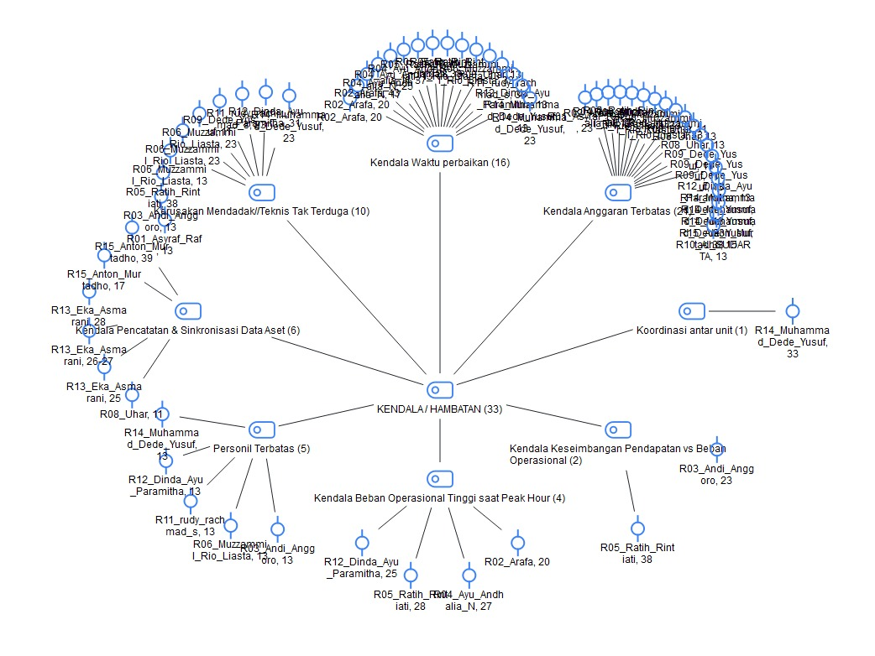
Figure 3. Coding Map of Constraints and Obstacles (MAXQDA)

Table 3. MAXQDA Coding Results Constraints and Obstacles Category
Code | Sub-category | Count | Reference Keywords
3.1 | Limited Budget | 21 | budget constraints, limited budget, insufficient budget, budget shortfall, budget capacity
3.2 | Spare-Parts & Procurement Constraints | 16 | procurement, lead time, spare-parts availability, price increase, import, discontinued parts
3.3 | Sudden Failure/Unpredictable Technical Issues | 10 | sudden failure, unexpected disruption, technical fault, overheat, error, false alarm, trip
3.4 | Asset-Data Recording & Synchronization Issues | 6 | asset recording, asset data, asset administration, unsynchronized data, differing age perspectives
3.6 | Limited HR/Personnel | 5 | personnel shortage, number of technicians, limited HR, personnel knowledge
3.7 | High Operational Load During Peak Hours | 4 | peak hour, equipment workload, rising operational load
3.8 | Revenue vs. Operational-Load Imbalance | 2 | revenue and operational load, balance between revenue and load
3.5 | Inter-Unit Coordination Constraints | 1 | coordination, cross-unit, synergy

Limited Budget emerges as the most prominent obstacle (21 codes), showing that maintenance, repair, and replacement needs must be adjusted to available funding and corporate priorities. Spare-Parts & Procurement Constraints (16 codes) further compound this, as certain components require long procurement lead times before facilities can be optimally restored. Sudden Failure/Unpredictable Technical Issues (10 codes) present a particular challenge for heavily used facilities that support continuous airport operations. Limited HR and high peak-hour operational load indicate that handling capacity is also affected by workforce readiness and field conditions. Although less frequent, Asset-Data Synchronization, Inter-Unit Coordination, and the Revenue-versus-Load Imbalance confirm that obstacles are not purely technical but also concern information quality, coordination, and decision-making. Collectively, the constraints to improving ME facility performance are multidimensional, spanning budget limitations, procurement and repair time, technical disruption, personnel shortages, operational load, and data/coordination issues — reinforcing the need for simultaneous technical and managerial support.

- Process, Impact, and Coordination
This category examines how ME facility management is carried out, its impact on operations, and inter-unit involvement. Coding shows that management relates to maintenance scheduling, priority-based decision-making, budget planning, cross-unit coordination, cost allocation, and impact on service, safety, and operational reliability, as illustrated in Figure 4.
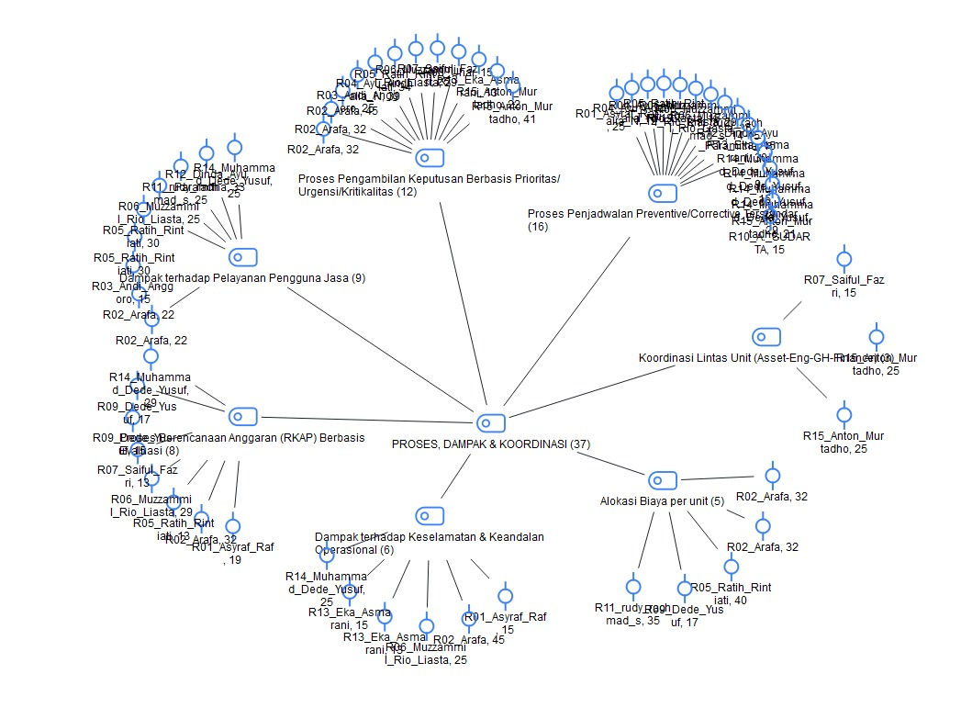
Figure 4. Coding Map of Process, Impact, and Coordination (MAXQDA)

Table 4. MAXQDA Coding Results Process, Impact, and Coordination Category
Code | Sub-category | Count | Reference Keywords
4.6 | Standardized Preventive/Corrective Scheduling | 16 | preventive maintenance, fixed schedule, routine, manufacturer recommendation, operating hours
4.4 | Priority/Urgency/Criticality-Based Decisions | 12 | priority, urgency, urgent, critical damage, delayed
4.1 | Impact on Service to Airport Users | 9 | service, airport users, comfort, satisfaction, operational service, good facility performance
4.3 | Evaluation-Based Budget Planning (RKAP) | 8 | RKAP, condition evaluation, work and budget plan, budget preparation, budget realization
4.2 | Impact on Safety & Operational Reliability | 6 | safety, reliability, security, safe and smooth, declining performance
4.7 | Cost Allocation per Unit/Machine | 5 | maintenance cost distribution, cost allocation, cost per unit/equipment
4.5 | Cross-Unit Coordination (Asset–Engineering–Ground Handling–Finance) | 3 | asset management, engineering, ground handling, cross-unit coordination, technical units

Standardized Preventive/Corrective Scheduling is the most frequent theme (16 codes), followed by Priority/Urgency/Criticality-Based Decisions (12 codes), indicating that management combines scheduled maintenance with urgency- and criticality-based handling of faults and replacement needs. On the planning side, Evaluation-Based Budget Planning (8 codes) and Cost Allocation per Unit/Machine (5 codes) reflect the link between technical needs and the budgeting process. Facility performance was also found to affect service to airport users (9 codes) and safety/operational reliability (6 codes), confirming that ME facility performance influences not only equipment condition but also service continuity and airport safety. Overall, facility management is a process integrating maintenance, decision-making, budgeting, and cross-unit coordination, underlining the need for technical-managerial integration to sustain service, safety, and operational reliability.

- Management Strategy
This category identifies approaches that can be applied to improve ME facility performance. Coding shows that strategies include strengthening preventive and predictive maintenance, priority-based budget management, phased asset replacement, HR competence development, cross-unit coordination, and criticality-based prioritization, as shown in Figure 4.5.
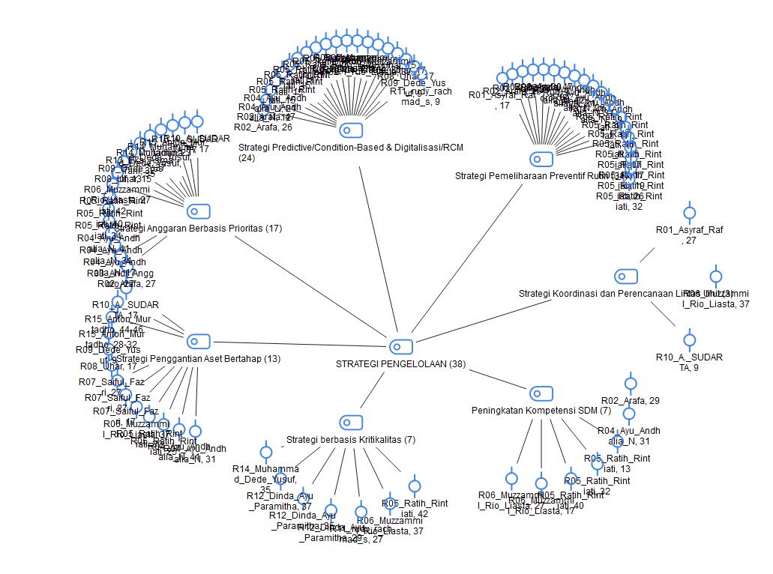
Figure 5. Coding Map of Management Strategy (MAXQDA)

Table 5. MAXQDA Coding Results Management Strategy Category
Code | Sub-category | Count | Reference Keywords
5.2 | Predictive/Condition-Based & Digitalization/RCM Strategy | 24 | predictive, condition-based, digitalization, monitoring, inspection, RCM, proactive
5.3 | Priority-Based Budget Strategy | 17 | priority needs, priority-based budget planning, sound planning, CapEx optimization, cost optimization
5.1 | Routine Preventive Maintenance Strategy | 16 | preventive, periodic maintenance, routine care, on a regular basis, responsive
5.4 | Phased Asset Replacement Strategy | 13 | phased replacement, asset replacement, replacing aged equipment, upgrade, rejuvenation, procurement
5.5 | HR Competence Development Strategy | 7 | technician capability, training, HR competence, capacity building
5.7 | Criticality/Service-Impact-Based Strategy | 7 | critical damage, service impact, facility priority, 5R method
5.6 | Cross-Unit Coordination & Planning Strategy | 3 | coordination, involved units, inter-unit cooperation, synchronization

The Predictive/Condition-Based & Digitalization/RCM strategy is the most dominant theme (24 codes), reflecting a shift toward proactive management through condition monitoring, inspection, and failure prediction. This is followed by the Priority-Based Budget strategy (17 codes) and Routine Preventive Maintenance (16 codes), underscoring the link between maintenance planning and funding capacity. The Phased Asset Replacement strategy is also prominent (13 codes), particularly for facilities nearing the end of their technical service life, while HR Competence Development and Criticality-Based strategies each appear 7 times, and Cross-Unit Coordination and Planning appears 3 times. Overall, these findings indicate that performance-improvement strategies are moving toward a more proactive, condition- and criticality-based approach, supported by budget prioritization and planned asset replacement — enabling maintenance and investment decisions that are better aligned with actual conditions and operational needs.

CONCLUSIONS AND RECOMMENDATIONS
Conclusion
This study concludes that mechanical-electrical (ME) facilities at Soekarno-Hatta International Airport generally remain capable of supporting airport operations despite asset aging and high utilization. Facility feasibility is determined not solely by equipment age but by the interaction of technical condition, operational load, failure history, spare-parts availability, and maintenance effectiveness. Current maintenance combines preventive, corrective, and predictive approaches according to facility condition and operational priorities.
ME facility performance is constrained by equipment deterioration, unexpected failures, limited repair time, technician capacity, spare-parts scarcity, budget limitations, lengthy procurement, and inconsistencies between technical and administrative asset data. Therefore, management should adopt an integrated condition-, risk-, criticality-, and life-cycle-based strategy through phased asset renewal, condition-based maintenance, CMMS optimization, technician development, spare-parts planning, risk-based budgeting, and stronger coordination among Engineering, Asset Management, Finance, and User units.

Limitations
This qualitative study focuses on a single airport and relies primarily on stakeholder perceptions obtained through interviews, observations, documentation, and MAXQDA-assisted analysis. The findings may therefore have limited generalizability and do not quantitatively measure indicators such as failure rates, downtime, maintenance costs, budget realization, or reliability across all ME facility categories.

Recommendations
Airport management should assess and prioritize ME facilities based on actual technical condition, service life, utilization, failure history, spare-parts availability, and operational criticality. Preventive, predictive, and condition-based maintenance should be strengthened through CMMS utilization, technician competency development, spare-parts planning, risk-based budgeting, updated cross-unit asset data, and regular coordination. Future studies should involve multiple airports and incorporate quantitative operational and financial indicators to validate and extend these findings.

Author Contributions
The author was responsible for the study’s conceptualization, literature review, methodology and instrument development, informant coordination, data collection, MAXQDA-assisted analysis, interpretation of findings, manuscript preparation and revision, and approval of the final version for publication.

REFERENCES
Aditya, P., Kumar, U., Galar, D., & Stenström, C. (2015). Performance measurement and management for maintenance: a literature review. Journal of Quality in Maintenance Engineering, 21, 2–33. https://doi.org/10.1108/JQME-10-2013-0067
Ali, L., & Ahmad, S. (2012). Statistical approach to determination of overhaul and maintenance cost of loading equipment in surface mining. International Journal of Mining Science and Technology. https://doi.org/10.1016/j.ijmst.2013.05.002
Crespo Marquez, A. (2023). Digital Transformation in Maintenance (pp. 67–75). https://doi.org/10.1007/978-3-031-25448-2_7
Emtaubel, S., Senussi, G., & Benisa, M. (2023). Improvement of the Maintenance Management system in a Petrochemical Complex and Reducing the Costs. مجلة الجامعة الأسمرية, 8, 136–158. https://doi.org/10.59743/jau.v8i4.1936
Iwarue, J. (2025). Impact of Preventive Maintenance Practices on Productivity. British Journal of Management and Marketing Studies, 8, 118–137. https://doi.org/10.52589/BJMMS-QRMKXG9R
Peng, Y., Zhang, Y., Hou, Y., & Liu, S. (2024). Service quality improvement strategies of online car-hailing based on SPC-PCN method. Electronic Commerce Research and Applications, 65, 101409. https://doi.org/https://doi.org/10.1016/j.elerap.2024.101409
Prichard, J. W. (1984). Equipment age-reliability anal ysis. September, 65–70.
Shrestha, P., Murrell, S., Aho, B., Williams, W., Ward, D., & Gad, G. (2024). Quantifying the Impacts of Delayed Maintenance of Airport Assets: A Guide. https://doi.org/10.17226/27960
Zonta, T., da Costa, C. A., da Rosa Righi, R., de Lima, M. J., da Trindade, E. S., & Li, G. P. (2020). Predictive maintenance in the Industry 4.0: A systematic literature review. Computers & Industrial Engineering, 150, 106889. https://doi.org/https://doi.org/10.1016/j.cie.2020.106889

