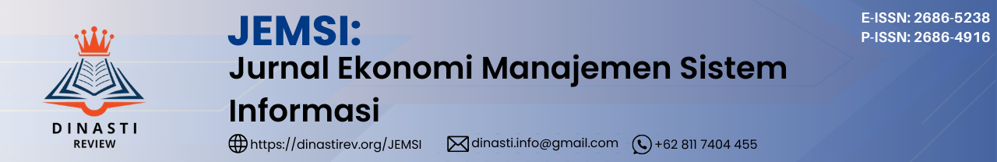

**DOI:** <https://doi.org/10.38035/jemsi.>v6i3

<https://creativecommons.org/licenses/by/4.0/>

**Digital Customer Relationship Management in Improving Service Quality Through E-Commerce Systems**

**Kasino Martowinangun1, Johni Setiady Pasaribu2, Jusuf Nurdin3**

1Politeknik Piksi Ganesha, Jawa Barat, Indonesia, [kasino.marto@gmail.com](mailto:kasino.marto@gmail.com)

2Politeknik Piksi Ganesha, Jawa Barat, Indonesia, [johnipa1000@gmail.com](mailto:johnipa1000@gmail.com)

3Politeknik Piksi Ganesha, Jawa Barat, Indonesia, [djusuf.n@gmail.com](mailto:djusuf.n@gmail.com)

Corresponding Author: [kasino.marto@gmail.com](mailto:kasino.marto@gmail.com)1

**Abstract:**Digital Customer Relationship Management (d-CRM) is an evolution of traditional CRM that focuses on the use of digital technology to manage customer relationships. In the context of e-commerce, “d-CRM” is a very important role in improving service quality through personalization, automation, and deeper utilization data of customers. This paper aims to explore how “d-CRM” can be applied in e-commerce platforms to improve service quality, customer satisfaction, and loyalty. By reviewing a case study on CV Bintang Raya Plastik and the literature, this article highlights the benefits of “d-CRM” and the challenges it in implementation.

**Keyword:** Digital Customer Relationship Management (d-CRM), E-Commerce, Service Quality, Customer Loyality, Automation, Personalization

**INTRODUCTION**

The development of information technology and the internet has changed many aspects of the business world, including the way companies interact with customers. One of the important elements in maintaining business sustainability and long-term success is effective customer relationship management. In the context of e-commerce, Digital Customer Relationship Management (d-CRM) is a strategy used by many companies to improve service quality, customer satisfaction, and loyalty through the use of digital technology.

In the digital era, businesses need to adapt their customer relationship management (CRM) strategies to be able to interact and retain customers effectively (Kumar, 2018). Digital CRM utilizes technologies such as artificial intelligence (AI), big data analytics, and marketing automation to improve customer experience, make data-driven decisions, and create more personalized marketing campaigns (Ledro, 2022).

The main goal of d-CRM is to make it easier for companies to manage interactions with customers efficiently and more personally. In an era where customers have instant access to a variety of products and services, providing a superior customer experience is a more differentiating factor. By integrating d-CRM with e-commerce platforms, companies can provide faster, more responsive, and more relevant services.

Traditional CRM focuses on collecting and managing customer information through manual processes and limited software. The goal is to maintain customer relationships, increase satisfaction, and manage sales through a centralized data center. This approach makes it easier for businesses to track interactions, sales activities, and identify opportunities for cross-selling or up-selling.

However, traditional CRM has its drawbacks, such as reliance on manual processes that are slow respons, inaccurate, and difficult to scale up (Reinartz, 2004). In the fact, the old CRM systems dificul to provide real-time customer data analytics, not optimal in decisions making and lost opportunities (Kumar, 2018).. The growth of technology and digital channels has transformed the way companies interact with consumers (Trainor, 2012). The traditional approach to CRM, which focuses solely on managing customer data and improving satisfaction, is no longer adequate to meet the demands of today’s increasingly connected customers (Choudhury, 2014). Today, companies are adopting digital CRM that emphasizes real-time, personalized, and seamless customer experiences across multiple devices. The differentiation of traditional and digital CRM, is the data-driven approach that enables a deeper understanding of customer needs in the real time (Kumar, 2018).

# **METHOD**

This SIM-SIS research uses the Prototype Method, which is one of the software development methods that uses an approach to create designs quickly and gradually, so that they can be immediately evaluated by users or clients. In this method, developers and clients work together and interact during the system prototype creation process. Often, clients only provide a general definition of what they want without mentioning in detail the input and output processes of the system to be created. To overcome this ambiguity, good cooperation is needed between the two so that developers truly understand the client's needs. Thus, the system designed will be more interactive and in accordance with needs.

The Prototype Method according to Pressman (Pressman, 2010) begins with gathering needs. Developers and clients meet to define the main objectives of the software, identify needs in terms of input, output format, and interface appearance. After that, a quick design is carried out. The results of this quick design are then tested and evaluated. A complete explanation of the prototype method will be explained through the image on the next page.

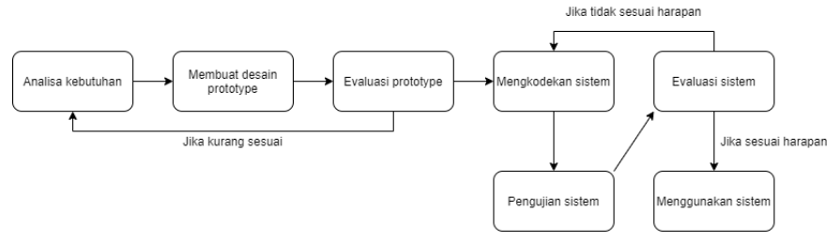

**Figure 1.** Metode of Prototype

Based on the results of the system requirements analysis that has been carried out, the next stage in the system development cycle is system design. At this stage, functional requirements definition activities are carried out as well as preparation for the design and implementation of the system to be created. This stage will also explain several important aspects in system design, such as Block Diagrams, System Flow, Input-process-output (IPO), Context Diagrams, Data Flow Diagrams (DFD) which describe data flow in the system, and Entity Relationship Diagrams (ERD) which show the relationship between tables in the database. ERD includes the Conceptual Data Model (CDM) and Physical Data Model (PDM), both of which describe the tables in the database that will be used to support data storage in the application. At DFD Level 0, the processes and data flows of the entire system as a whole are described.

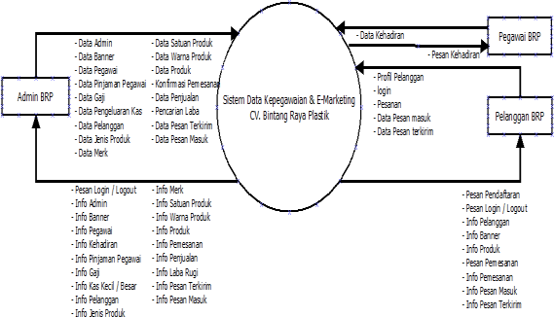

**Figure 2.** DFD Level 1

# **RESULTS AND DISCUSSION**

**Results**

CRM is not a new concept in business management, but with the development of technology, there has been a change in its implementation in companies (Muhtadi, 2018). Since the advent of sales automation software (SFA), CRM has shifted its focus to one-to-one marketing. SFA helps automate routine tasks such as tracking contacts and predicting customer prospects (Olomu, 2019). The goal is to give salespeople more time to focus on sales activities rather than administrative work.

In general, CRM is a part of marketing that focuses on customer relationships with the aim of increasing long-term profitability. The focus of CRM has changed from transaction-based marketing, which emphasizes acquiring new customers, to customer retention through effective relationship management (Adithya, 2021).

CRM is a more sophisticated and complex application because it is able to mine customer data from every point of interaction. This allows for a comprehensive view of customers, so that their habits can be analyzed (Haryanto, 2018).

Technology that tracks and analyzes customer behavior allows companies to identify the best customers. In this way, marketing strategies can be focused, and rewards are given to loyal customers (Komalasari, 2021). Understanding customers in depth allows companies to interact, respond, and communicate more effectively, which ultimately increases customer retention (Endrawati, 2018).

Technological innovation, increasing competition, and the internet world are some of the factors that facilitate one-to-one marketing initiatives between companies and customers (Lam, 2019). This one-to-one relationship allows companies to customize shopping experiences, predict purchasing patterns, attract customers with special offers, evaluate the economic benefits of each customer, and build long-term, mutually beneficial relationships (Courchesne, 2019).

The rapid growth of e-commerce presents new challenges for companies looking to develop e-commerce strategies. This is due to the nature of information technology that continues to develop without stopping (Cahyono, 2018). The main concern of companies in e-commerce promotion strategies is the loss of customers due to competitors who are able to implement better e-commerce strategies (Abdiansyah, 2021).

E-commerce has attracted the attention of many researchers since its emergence, so its definition has varied. Roger Clark defines e-commerce as the activity of buying and selling goods or services through communication tools, while Jerry Ellison describes it as an electronic contract for the exchange of value using information and communication technology (Kethineni, 2018). Anil Khural added that e-commerce involves the use of internet technology, computers, and software to send and receive product data, orders, and other information needed by customers, suppliers, or the public (Babenko, 2019).

Based on these various definitions, e-commerce can be interpreted as:

1. In a narrow sense, e-commerce is a financial transaction via the internet or a private communication network that involves the purchase or sale of goods and services, as well as the transfer of money (Chen, 2021).
2. In a broad sense, e-commerce covers all business relationships between various actors through the use of internet technology (Zaelani, 2019).

**Discussion**

The following is the implementation of the digital CRM interface in the e-commerce system in improving the quality of service at CV. Bintang Raya Plastik. The main page of the CRM-based e-Commerce application at CV Bintang Raya Plastik provides limited access rights for customers who have not registered as members. They can only view products, view company profiles, FAQ services, and view other registered members. However, they cannot send messages to the admin or make product requests and orders.

The main page of the CRM-based e-Commerce application at CV Bintang Raya Plastik provides limited access rights for customers who have not registered as members. They can only view products, view company profiles, FAQ services, and view other registered members. However, they cannot send messages to the admin or make product requests and orders.

Full access rights will be given after the customer registers and confirmation is made by the admin. Customers or prospective customers must first log in to the system in order to exchange data and information on the CV Bintang Raya Plastik website. The main page of the CV Bintang Raya Plastik website has several menus, namely homepage, profile, products, shopping cart, catalog, and contact us. The profile menu contains information about the company CV Bintang Raya Plastik, while the product menu contains information about the types of products sold. The shopping cart functions to store products ordered by customers. The how to buy menu provides guidance on the ordering, purchasing, and payment processes. The catalog contains a list of products sold and can be downloaded by customers. Meanwhile, the contact us menu is used for confirmation or to provide criticism and suggestions. To be able to carry out the customer login process and the registration process, users must access the website address, then enter a username and password to log in (shown in Figure 3).

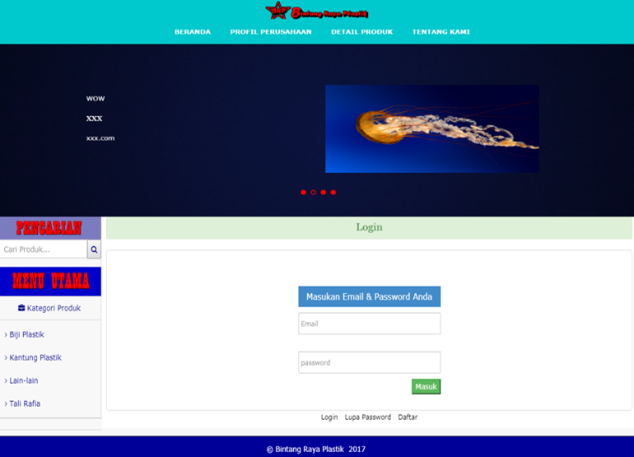

**Figure 3.** Dialog Screen of Customer Login

On the product page, there is detailed information about the products sold. Customers can also view the company's complete product catalog, access product information and place orders (Figure 4). To view product information, click the Detail button in the lower right corner of the product box, then a Frame will appear containing details of the selected product as in Figure 5. After finishing selecting a product, customers can update the shopping cart, such as adding the number of products they want to buy or adding other products, as shown in Figure 5.

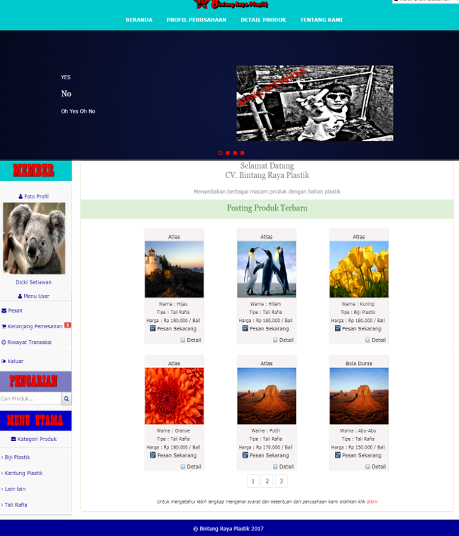

**Figure 4.** Dialog Screen, Main Customer Dashboard

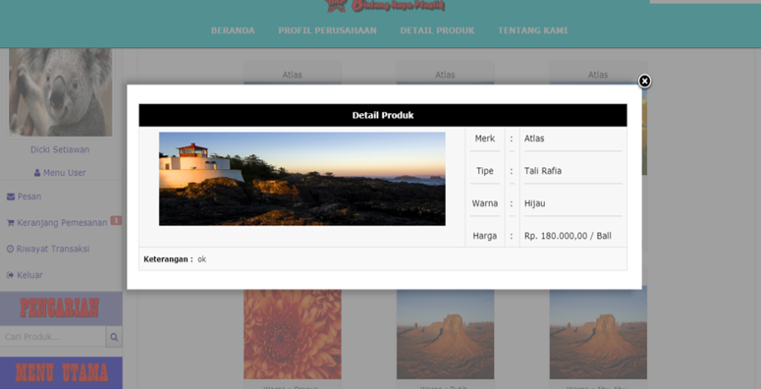

**Figure 5.** Dialog Screen Details Product

Next, to order a product, click the Order Now button at the bottom of the product box. And an IFrame will appear containing the Product Order Form as shown in Figure 6. Then after the order is successful, the Order Basket menu will display a Notification Icon indicating the number of orders made by the customer as shown in Figure 7.

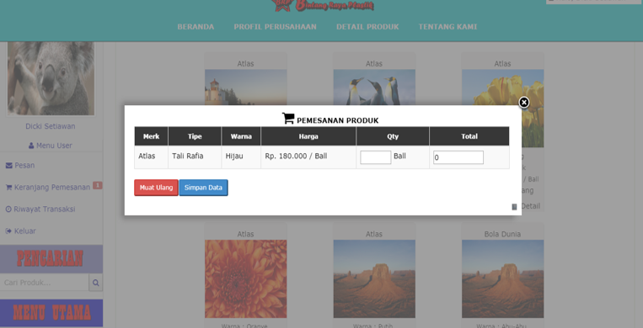

**Figure 6.** Dialog Screen Product Order

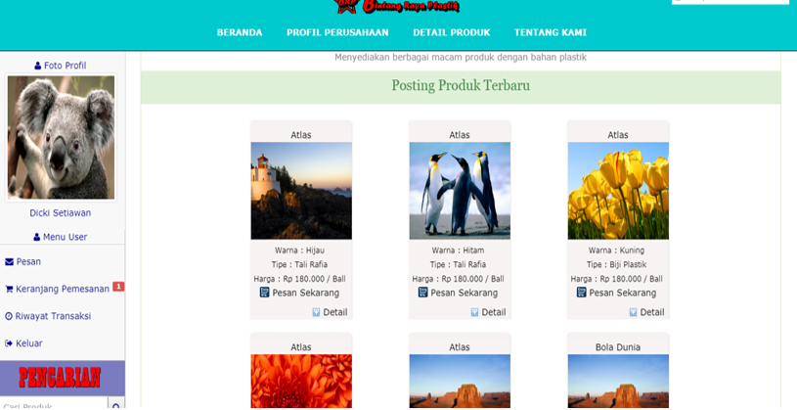

**Figure 7.** Dialog Screen, Box Product Order

The notification icon in the order basket is in the form of a number indicating the number of orders that have been made by the customer and have not been confirmed by the administrator. And if the number of orders in the order basket has reached the maximum order limit of 5 orders, the customer cannot order the product. If the customer places an order after having 5 unconfirmed orders, a notification message will appear as in Figure 8

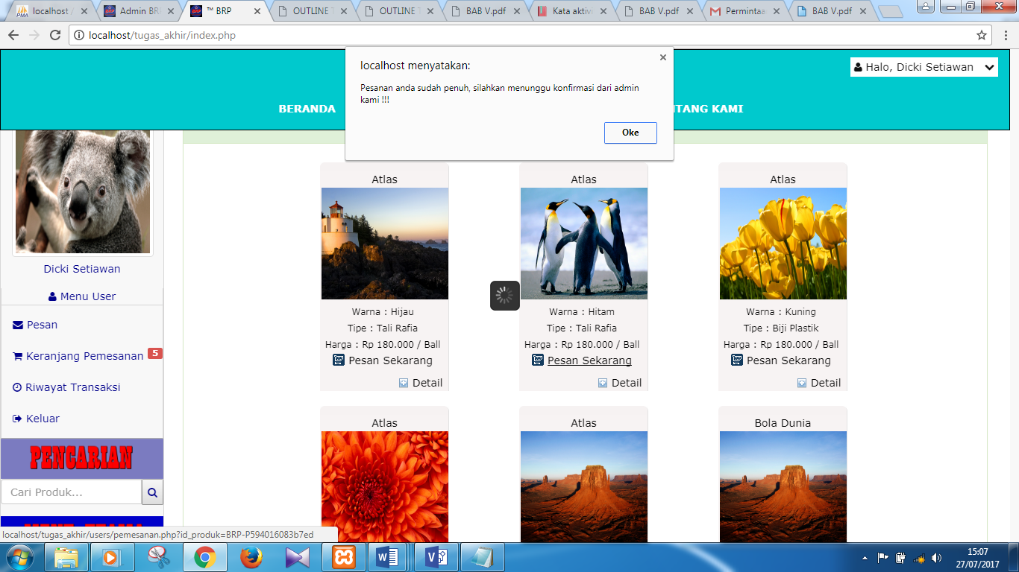

**Figure 8.** Dialog Screen, Full fill Order

To see orders that have been made, click the Order Basket menu and a frame will appear containing order data that has not been confirmed by the administrator, as shown in Figure 9.

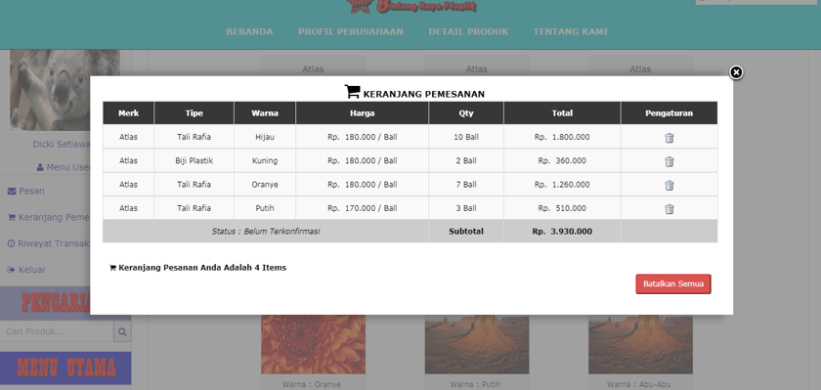

**Figure 9.** Dialog Screen, List of Box Order

If the order has been confirmed by the administrator, the customer will receive a confirmation message that the product order is accepted or rejected by the administrator. The order confirmation message will be displayed in the Message menu in the customer's Inbox with a Message Notification Icon containing a number stating the number of unread incoming messages. For more details, it will be displayed in Figure 10.

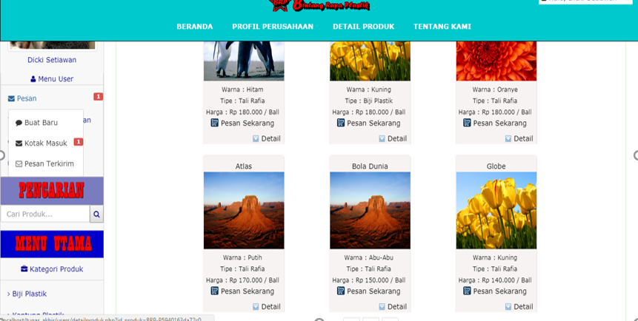

**Figure 10.** Dialog Screen, list of Product Order

It can be seen in Figure 11 that there is an incoming message notification icon indicating that there is an incoming message that has not been read by the customer. In this discussion, the incoming message contains a confirmation of the order made by the administration. To see the incoming message, click the Inbox menu and it will appear as in Figure 11.

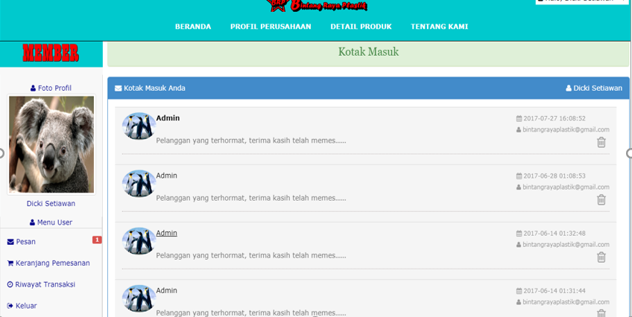

**Figure 11.** Dialog Screen Customer Communication

**CONCLUSION**

Digital Customer Relationship Management (d-CRM) in the context of e-commerce plays a vital role in improving service quality and customer experience. With the ability to personalize interactions, automate processes, and analyze customer data, d-CRM enables companies to deliver more efficient and relevant services. While there are some challenges in its implementation, the long-term benefits of d-CRM can provide significant competitive advantages for e-commerce companies.

**REFERENCE**

Abdiansyah, T. (2021). Inovasi Transaksi Ekonomi Berbasis Digital di Pasar Tradisional Probolinggo. *Jurnal Sosial Politik Integratif, 1*(3), 1-9.

Adithya, A. R. (2021). Sistem Informasi E-CRM Berbasis Web Untuk Peningkatan Loyalitas Serta Pelayanan. *Jurnal Portal Data, 1*(2).

Babenko, V. K. (2019). Factors of the development of international e-commerce under the conditions of globalization. *SHS Web of Conferences*, *65*, p. 04016.

Cahyono, G. H. (2018). Kewirausahaan dan Inovasi dalam E-Commerce. *Swara Patra, 8*(1), 80-92.

Chen, Y. &. (2021). Investigation of finance industry on risk awareness model and digital economic growth. *Annals of Operations Research*, 1-22.

Choudhury, M. M. (2014). CRM to social CRM: the integration of new technologies into customer relationship management. *Journal of Strategic Marketing, 2*, 149–176.

Courchesne, A. R. (2019). Using Technology to Optimize Customer Relationship Management: The Case of Cirque du Soleil. *International Journal of Arts Management, 21*(2).

Endrawati, D. &. (2018). Hubungan Kualitas Layanan dengan Kepuasan Pelanggan PT. Indoguna Utama Semarang. *Majalah Ilmiah Inspiratif, 3, 6*.

Haryanto, H. &. (2018). Model Manajemen Hubungan Pelanggan dan Sistem Bisnis Intelijen untuk Katalog Secara Online. *Prosiding Seminar Nasional Rekayasa Teknologi Informasi SNARTISI*, *1.*

Kethineni, S. C. (2018). Use of bitcoin in darknet markets: Examining facilitative factors on bitcoin-related crimes. *American Journal of Criminal Justice, 43*(2), 141-157.

Komalasari, D. P. (2021). *Buku Ajar Digital Marketing.* Umsida Press.

Kumar, V. a. (2018). *Customer Relationship Management.* Berlin: Springer.

Lam, C. &. (2019). Readiness of upscale and luxury-branded hotels for digital transformation. *International Journal of Hospitality Management, 79*, 60-69.

Ledro, C. N. (2022). Artificial intelligence in customer relationship management: literature review and future research directions. *Journal of Business & Industrial Marketing, 37*(13), 48-63.

Muhtadi, A. S. (2018). Strategi Indosat Mempertahankan Pelanggan melalui Customer Relationship Management. *Reputation: Jurnal Hubungan Masyarakat, 1*(2), 70-88.

Olomu, M. O. (2019). Marketing automation innovation practices and customer retention performance: evidence from the Nigerian manufacturing SMEs. *International Journal of Business Performance Management, 20*(3), 212-228.

Pressman, R. S. (2010). *Rekayasa Perangkat Lunak Pendekatan Praktis.* Yogyakarta: Andi.

Reinartz, W. K. (2004). The Customer Relationship Management Process: Its Measurement and Impact on Performance. *Journal of Marketing Research, 41*(3), 293–305.

Trainor, K. J. (2012). Relating Social Media Technologies to Performance: A Capabilities-Based Perspective. *Journal of Personal Selling & Sales Management, 32*(3), 317–331.

Zaelani, I. R. (2019). Peningkatan Daya Saing UMKM Indonesia: Tantangan dan Peluang Pengembangan Iptek. *Jurnal Transborders, 3*(1), 15.